There are now a total of 40 GPIO pins, 26 of which can be used as digital inputs or outputs. Perhaps more importantly, 9 of the 14 new GPIO pins are dedicated inputs/outputs (pins which do not have an alternative function), so now if you want to use the onboard UART, I2C or SPI bus you can do so and still have plenty of free GPIO inputs and outputs to play with. The new expanded GPIO pinout is as shown below.

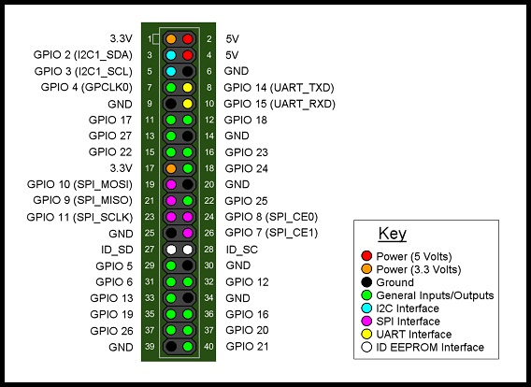

Pins 3 and 5 (GPIO 2 and GPIO 3) both have on board 1.8KOhm pull-up resistors fitted to them (and they also double up as the I2C interface pins). Pins 27 and 28 (ID_SD and ID_SC) are reserved exclusively for ID EEPROM use and can not be used as input/output pins. The layout of the GPIO pins is backwards compatible with previous Raspberry Pi models – pins 1 to 26 are directly compatible with previous Raspberry Pi GPIO headers, although it should be noted that the whole GPIO header has been moved away from the corner of the board to allow room for an additional mounting hole - therefore any plug in board designed for previous Raspberry Pi models may be compatible, but will not sit directly above the Raspberry Pi B+ board because the GPIO header has been repositioned.